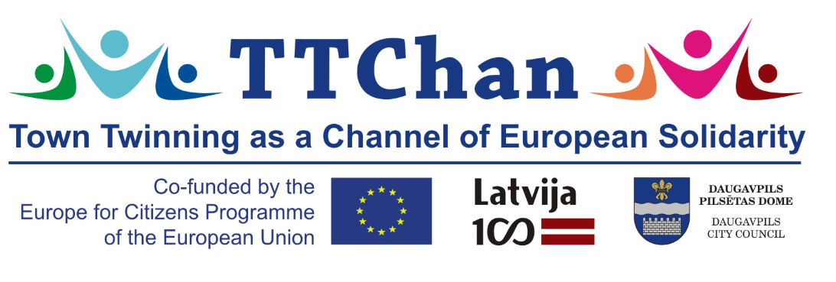
Town Twinning as a Channel of European Solidarity

8th November- 12th November 2018 in DAUGAVPILS, Latvia

08.11.2018. Arrival of participants, Transfer from Airport Riga 15:00
Check-in at hotel, Hotel ”Latgola”, Ģimnāzijas 46, Daugavpils
Welcoming, Ice-breaking dinner 19:30, Restaurant “Plaza”, Ģimnāzijas 46, Daugavpils
_________________________________________________________________________________

09.11.2018. Kick-off day - presentation of project idea, project partners, meeting with authorities
Daugavpils City Council, K.Valdemara 1, Daugavpils, City Council Hall
9:00-10:00 Official opening ceremony of the project, speeches of authorities
Mayor/ 1st Deputy of Daugavpils City Council
Daugavpils is Diversity - city presentation, Development department, Jolanta Reča-Lāža
Introduction round: brief presentation of each City (max 5 min, PowerPoint or video or speech)
Signing of Memorandum of Collaboration between Daugavpils, Latvia and Raska, Serbia

Daugavpils University, Conference Hall - 130, Parades 1A, Daugavpils
10:30 – 11:30
Town Twinning as a Channel of European Solidarity - project presentation
Jolanta Ūzuliņa, Development department, Daugavpils City Council
Solidarity and intercultural synergy - best practices (each partner 10 min)

Agenda of the project: project important, mass media interviews (with each partner)
11:30-12:00 coffee break

12:10-12:30 Latvia’s Centenary - the catalyst for co-operation
Leonarda Ķestere, Head of International Program, Latvian Centenary Office, Ministry of Culture LR
12:30-14:30
Daugavpils democratic engagement and civic participation in European context
Dr.psych.Aleksejs Ruža, associate professor, head of psychology programs at Daugavpils University
Debate on Future of Europe - how do we see it?
Discussion on understanding and debating Euroscepticism
Work Shop - The image of my city/country
14:45-15:30 Lunch, Latgola, Restaurant “Plaza”, Ģimnāzijas 46, Daugavpils

15:30-16:30 Free time (optional: Daugavpils Museum – red and white ribbon braiding)
16:30 Transfer from Hotel to Daugavpils Fortress
17:00-19:00 Daugavpils Fortress and Daugavpils M.Rothko Art Center
19:30 – Intercultural dinner, Hotel “Latgola” – Lobby Bar, Ģimnāzijas 46, Daugavpils
___________________________________________________________________________

10.11.2018. Democratic engagement and civic participation
9:00-18:00 Latgale region tour
The Naujene castle hill, 24 m high sightseeing tower at Daugava river, Kraslava Castle complex,

Center Latgale Culinary Heritage Centre, Basilica of the Assumption in Aglona, Aglona bread museum.

19:30 – Festive dinner, Restaurant “Irish Dublin Pub”, Viestura 10, Daugavpils

___________________________________________________________________________

11.11.2018. Sharing, understanding, solidarity and intercultural synergy in Daugavpils, Latvia and Lāčplēsis day - European heritage
10:00-11:30 Conference Hall Latgola / Daugavpils City Council Hall
Discussion on program Europe for Citizens town twinning importance
Free discussion “What can I do to promote my partner?”
13:00-14:00 Lunch, Restaurant “Plaza”, Ģimnāzijas 46, Daugavpils
14:00-17:00 free time
17:00 Taking active part in Lāčplēsis Day. Torchlight procession
Lāčplēsis Day is the Latvian Patriotism Day
19:30 Farewell dinner, Restaurant “Plaza”, Ģimnāzijas 46, Daugavpils _________________________________________________________________________________

12.11.2018. Town twinning importance, project evaluation
9:30 Reflection on the benefits of the project and gaining of experience for future cooperation
Project evaluation (pluses, minuses, suggestions)

11:00 Transfer to Riga Airport (Lunch packets to go)

Contact: Olga Tolmačova
Head of office for Strategic planning and international affairs
Development department, Daugavpils City Council, Latvia
Olga.tolmacova@daugavpils.lv, m.+371 20089634

